To: Council

Date: 21 February 2024

Report of: Head of Financial Services

Title of Report: Chief Finance Officer’s report on the robustness of the Council’s 2024/25 budget

Summary and Recommendations
Purpose of report:
Under Section 25 of the Local Government Act 2003 there is a requirement for the Council’s Chief Financial Officer to report to Council on:
a) the robustness of the estimates made for the purposes of the calculations of the budget; and
b) the adequacy of the proposed financial reserves.

Council in considering its Budget should have regard to this advice.

Recommendation: That Council notes this report in setting its budget for 2024/25 and the indicative budgets for 2025/26 – 2027/28.

Appendix 1: Statement of Reserves and Balances

Introduction
- The financial backdrop of Local authorities is not a good one. There have been a significant increase this year in the number of local authorities issuing Section 114 notices, effectively declaring bankruptcy and many more threatening to take similar action. It is reported there is a £2 billion funding gap in 2024-25 and the provisional financial settlement provides only limited additional financial support. Many tier 1 authorities are straining under the weight of increasing demand especially adult social care and tier 2 authorities like Oxford have similar problems especially around temporary costs which are already for this year spending £1million over budget and rising.
- The Council has yet to obtained an audited set of accounts for 2021-22 and 2022-23 and therefore to certain extent estimates have had to be made of the outurn position of the council and therefore the position of reserves and balances.
- The Councils Budget and Medium Term Financial Plan is balanced over the next 5 year period although the budget proposes reductions in core services such as street cleaning, waste and recycling and also Community Services such as leisure and voluntary sector grants and in addition around £7million is proposed to be taken from reserves.
- If ever there was a time to ensure the robustness of budgets and adequate reserves are maintained, now is the time. This report to Council is a statutory requirement of the Councils Chief Financial Officer under Section 25 of the Local Government Act 2003, to report to Council on:
- The robustness of estimates made for the calculation of the budget
- The adequacy of reserves
4 Council are required to consider this report alongside the budget setting discussions.

Preparation of the Medium Term Financial Plan
- As in previous years the Council has undertaken a prudent and robust approach in developing its Medium Term Financial Strategy (“MTFS”) based on information that is available to date and prudent forecasts of the income and expenditure that will be arise whilst undertaking it’s services.
Robustness of Estimates
      - All aspects of the Council’s budget, efficiency savings, additional income streams, and pressures have been subject to rigorous review, with Service Heads being required to review the plans they put forward in previous years and confirm delivery of the proposals over the life of the MTFS.
      - Scrutiny of the budget has been undertaken by
- The Finance Team
- Directors and the Chief Executive
- Executive Members
- The Scrutiny Committee’s Finance Panel
- Monitoring of the budget through the year is undertaken by Financial Services in conjunction with Heads of Service and Cost Centre Managers to ensure that the budget is on target or variations are reported and acted upon at an early stage. Monthly monitoring reports are considered by Heads of Service at the Council’s Operational Delivery Group and Corporate Management Team with quarterly updates presented to Cabinet.
- The Council has established a Project Management Office to oversee and undertake project management of projects within the Council’s Capital Programme. Potential projects are subject to more rigour and resources are spent on establishing the feasibility and outline business case before a bid is made through Cabinet and Council for budget approval of funds to carry out the project.

General Fund Assumptions
- Assumptions on which the four year MTFS are based are contained within the main budget report presented elsewhere on the agenda, however, the key assumptions include:
- Council Tax increase - The Council Tax increase is 2.99% for 2024-25, in line with the referendum limit set by the Government for both 2023-24 and 2024-25. It is assumed that this increased at the previous referendum limit of 1.99% thereafter.
- Income Streams – income streams especially those susceptible to supply and demand have been budgeted prudently. Car parking income for instance have not returned to pre Covid levels. Town Hall income from lettings is forecast to return to normal levels from 2024-25. Commercial rent income ae now back to pre Covid levels although this has been partly due increased investment and regeneration schemes such as George Street and Odeon
- Investment Interest – On the 13th December 2023 the Bank of England maintained base rates at 5.25%. Latest forecasts predict base rates to remain at this level until quarter 3 of 2024 before falling back slowly to 4.25% by 2026.
- OxWed Development – Income yield from the councils partnership in Oxwed LLP continues at 6.5% on the amount invested which currently stands at £13.3 million. Planning approval is under consideration and alongside it the delivery strategy which will move the project closer to the delivery of financial returns to the Council and its partner Nuffield College.
- Oxford Direct Services Ltd - The updated ODS Business Plan includes ambitious targets to generate additional turnover for the companies trading arm ultimately improved dividend return to the Council. Profit after tax is estimated at around £5.1 million by 2026-27.
- Oxford City Housing Ltd –Dividend returns from the Company are expected to be around £10.9 million over the MTFS in addition to marginal returns of interest on monies borrowed.
- Borrowing - Due to the scale of investment over the period to 2024/25 to 2027/28, including the loans to the Council’s Housing Company (£100.7 million), the level of prudential borrowing will increase to over £904.3 million in 2027/28 from the projected £394.0 million at the end of 2023/24. Borrowing from internal resources will be maximised on the General Fund, however much of the borrowing will need to be from external resources with anticipated external borrowing increasing from £198.5 million to £795.5 million in 2027/28. The Housing Revenue Account Capital Programme is largely funded from council house rents over time but includes £413.4 million borrowing from 2023/24 to 2027/28
- Retained Business Rates – The MTFS includes estimates of the amount of Retained Business Rates income for the authority, based on the Government’s indication of tariffs and baseline income for 2024-25. The Government have indicated that fairer funding and business rates reset will be delayed until 2025-26. There remains uncertainty after this date for which a provision has been built into the MTFS.
- Pay Assumptions – Last year the Council agreed a 2-year local pay deal with the staff unions, commencing 1st April 2022 of 2% and 2.5%. In December 2023 unions balloted members and overwhelmingly agreed to accept a two year deal
  - 6.5% increase from 1-4-2024
  - 3% increase from 1-4-2025
- Inflation – With the exception of contractual inflation e.g. Leisure contract and ICT maintenance contracts and pay budgets all other budgets are cash limited.

Housing Revenue Account (HRA) Assumptions
- The Scrutiny of the HRA budget and Business Plan has followed a similar process to that for the General Fund outlined above.
- Key assumptions in the HRA budget include:
- Rent Setting
The Council has approved an increase of 7.7% for 2024/25 in social dwelling rents from 1st April 2024 giving an average weekly increase of £9.27 per week, and a revised weekly average social rent of £129.72.
- Debt Management Strategy
The HRA Capital Financing Requirement (CFR) will increase from an estimated £298 million at the 31-3-2024 to £639 million by 31-3-2028. Overall external debt will rise to an estimated £795 million at the end of this period, much of it in relation to the increased HRA CFR. Sufficient provision has been made in the HRA to cover the cost of this debt.
- Inflation and pay assumptions
All the assumptions for pay inflation are the same as for the Council’s General Fund.

Capital
- The Council has set an ambitious Capital Programme for the next four years in excess of £750 million.
- The preparation of the Capital Programme has undergone similar scrutiny to the other areas of the Council’s budget with the Development Board having an oversight of all new bids. Contingencies are included within individual schemes for variations in spend with any other variations outside these amounts being subject to the normal virement and supplementary estimate approvals set out in the Council’s Financial Rules. For this year a 40% optimism bias has been built into the capital budget. This a recognised methodology which highlights the tendency for project managers to be overly optimistic on how much of the capital programme that can be delivered. This has the effect of reducing the programme down to £550 million over the MTFS.
- Financing of schemes within the Programme is predominantly through borrowing which at £678 million over the 4 year programme represents 74% of the total programme. Most General Fund additional borrowing is in relation to loans to the Council’s Housing Development Company (OCH(D)L) with the HRA borrowing being in relation to the purchase of social housing units from OCH(D)L.

Adequacy of Reserves and Balances
- The prudent level of reserves that the Council should maintain is a matter of judgement. Generally the higher the risk of the council’s financial plans the higher the level of reserves and balances. The Oxford Model’s reliance on income streams from its wholly owned companies and other sources of income such as commercial rents (as illustrated below) is more of a risk than simply reducing spend. In such situations it is prudent and advisable to hold an adequate amount of reserves and balances to deal with any volatility in these areas.
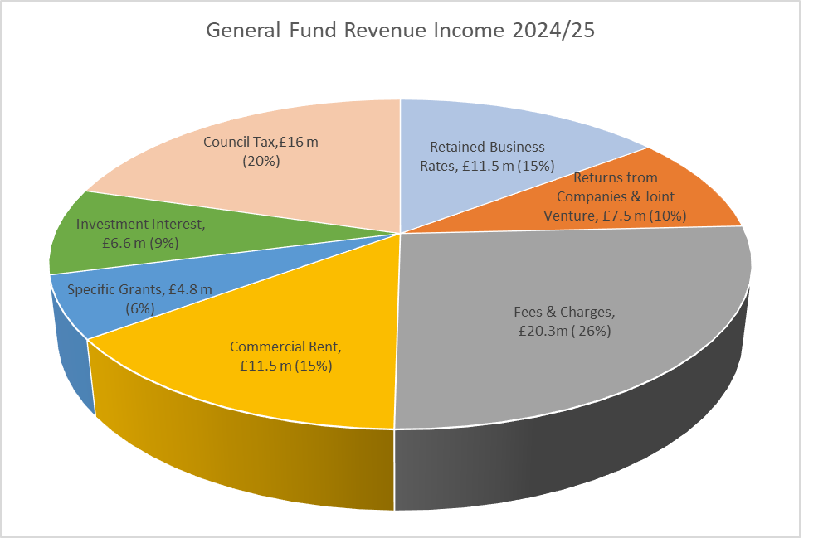
- The level of the Councils overall reserves and balances is shown in Appendix 1 and summarised in Table 1 below:

STATEMENT OF RESERVES AND BALANCES |  |  | APPENDIX 1
Reserve Name | Current Balance @ 01/04/2023 | Expected balance 01/04/2024 | Forecast Balance 31/03/25
Other Earmarked Reserves
Sub total | -37,699,364 | -25,965,737 | -22,225,737
Ringfenced reserves funded by 3rd parties
Sub total | -9,276,649 | -5,766,649 | -4,176,649
Other Ringfenced reserves
Sub total | -897,791 | -897,791 | -897,791
Self Insurance Fund | -1,164,556 | -1,164,556 | -1,164,556
TOTAL GF Earmarked Reserves | -49,038,359 | -33,794,732 | -28,464,732
 |  | 0 | 0
TOTAL HRA Earmarked Reserves | -11,418,797 | -10,418,797 | -9,418,797
TOTAL ALL earmarked reserves | -60,457,156 | -44,213,529 | -37,883,529
General Fund Working Balance | -4,000,000 | -4,000,000 | -4,000,000
HRA Working Balance | -3,500,000 | -3,500,000 | -3,600,000
Notes
- Ring fenced accounts funded by third parties which must be repaid if not used for the purpose specified, e.g. Salix Funds and Section 106 commuted sums
- Other ring fenced accounts -reserves which have a statutory limitation on their use; such as the Taxi Licensing Reserve, grants reserved and the HMO Licensing Reserve
- Other earmarked reserves which have been earmarked but are largely unspent
- Accounts which it is considered prudent to set aside for a specific purpose such as the Insurance Fund
- Working balances – are funds which are not ringfenced for any purpose
- Table 1 indicates that General Fund unringfenced earmarked reserves and balances will reduce from £42 million at 31-3-2023 to an estimated level at 31-3-2024 of £30 million and then to an estimated £26 million by 31-3-2025. Other points worthy of note :
- Ringfenced reserves relating to grants, licenses, HMO, Salix and Commuted sums can only be used for the specific purposes.
- Unringfenced earmarked reserves – such reserves are generally held for specific purposes to cover risk but are not ringfenced. Reserves in this category include the employee reserve or NNDR which protect the revenue account against swings in spend, reserve or to help finance schemes such as the ‘capital financing reserve’ or ‘vehicle replacement reserve’. The use of any of these reserves other than for the purpose they have been established will have a financial consequence and will reduce the financial resilience of the Council. These reserves General Fund Revenue deficits are estimated to reduce to around £22 million by 31st March 2025 including £6million in the risk reserve to be used over the remaining MTFP period
- The Councils General Fund working balance remains at around £3.8 million throughout the period of the MTFS, this represents the only unfettered reserve held by the Council.
- The HRA working balance is estimated at around £4 m representing around 8% of gross rental income, sufficient to meet any unexpected financial issues that may arise.

Financial Resilience
- The consequence of not keeping a prudent level of reserves can be significant. In the event of a serious problem, or a series of events can have a significant impact on the Councils finances such as a downturn in the financial position of ODS or reduced activity in OCHL as has been recently seen this can have or a reduction in the value of the Council’s property investments it could lead to less return for the Council and potentially a deficit position. In the absence of reserves the Council would be forced to cut expenditure in a damaging or arbitrary way.
- The Chartered Institute of Public and Finance and Accountancy (CIPFA) has stated that there should be no imposed limit on the level or nature of balances required to be held by an individual Council. However, for a district council, where changes to a few areas can have a disproportionate impact, a higher percentage of level of reserves to net expenditure is desirable. The level of balances to be held is largely a matter of judgement for the Councils Section 151 Officer based on local circumstances such as the level of activity in the council, the risk appetite of the council, the council’s reliance on income streams and gross expenditure.
- CIPFA undertake a survey of councils to understand their financial resilience. By analysing data from individual councils and providing comparisons on a number of key financial areas, CIPFA place a risk rating against each of these measures in terms high, medium and low risk. The last exercise undertaken was in December 2022 based on financial information for 2021-22 but may still provide a useful indication of how the council stands compared to these indicators.
- The main observations in comparison to other non-metropolitan districts was as follows:
- The ratio of Council tax income as a proportion of net expenditure was 38% for Oxford against a range of 34%- 100% for other local authorities. The authority was deemed low risk, which is surprising.
- The ‘Oxford Model’ relies on significant income streams to fund its gross expenditure. Fees and charges as a ratio to service expenditure is 25% against a range of 1.37% to 57% for other local authorities. This ratio will increase over the life of the MTFP given the reliance on financial returns from OCHL and ODS and although deemed low by CIPFA is certainly one to closely monitor.
- The high percentage of business rates growth above baseline for Oxford City Council at 74% within a range of -153% to 435% is reflective of the opening of the Westgate Shopping Centre and is deemed medium to high risk.
- At £3.8 million the General Fund Working Balance at around 10% of net revenue expenditure. Whilst this was far short of the upper end of the sample group at 300% and is considered high risk, it is still considered by the Council’s Section 151 Officer to be a reasonable level for this authority especially when combined with earmarked reserves.
Sensitivity Analysis
- Risks remain around fluctuations in the council’s incomes and expenditure. Whilst it is unlikely that there would an adverse impact on all of these areas all at once should this happen then reserves would be required to cover the resultant shortfall. The following analysis indicates the financial impact of a 10% variation on significant items of income and expenditure.
10% Variation in Income And Expenditure
 | Gross  £000's | Risk  £000's
Additional efficiencies and fees and charges | 3,200 | 320
Car Parking Income | 7,109 | 711
Commercial rent income | 12,414 | 1,241
Business Rates | 11,100 | 1,100
Returns from companies an joint ventures | 7,964 | 796
Other investment interest | 1,551 | 155
Homelessness expenditure | 2,969 | 297
Planning income | 2,253 | 225
Total | 48,460 | 4,845
Treasury Management
- Reserves and Balances are an essential part of cash balances on which the Treasury function is based. Whilst waiting to be used they will attract interest of currently around 3% per annum depending how they are invested. Longer term investments such as property funds and lending to companies including the Council’s wholly owned companies will attract interest in the region of 5%, while investments held for short term liquidity purposes will be at the lower end.
- The budget for investment net interest from company lending, HRA and investments is £6.5 million per annum. Reserves and balances can also be ‘internally borrowed’ essentially deferring the need to borrow externally to meet capital commitments. Such borrowing is currently cheaper than accessing external borrowing sources such as the Public Works Loan Board (PWLB).
Progress on the 2023/24 Budget
- Budget monitoring for the 6 months ending 31 December 2023 indicates an outurn budget deficit of around £1.000 million. If outurn remains at this figure this deficit will need to be met from reserves and balances referred to in this report.
Conclusion
- I have reviewed the budget preparation process for 2024-25 to 2027-28 and the level of reserves and balances. The Council still faces significant financial challenges in a number of areas including
- Business Rates Retention – no further announcements were made by the Government in the Provisional Finance Settlement about business rates reset and fairer funding and the authority must therefore assume that this will be implemented as planned in 2025-26. Provision has been made in the budget for this although in reality it is still no clearer how this will affect the authority
- Pressures around income streams especially commercial rents brought and car parking income. Prudent estimates have been made of the likely estimated position of these income streams.
- The success of the council’s wholly owned companies will be key to its financial success with returns and dividend over the MTFS of around £37 million. The performance of these companies will need to be closely monitored.
- Efficiencies and increased income changes – the Councils plans to increase efficiencies and increased income by another £11.6 million by 2027-28 which will need close monitoring to ensure delivery.
- In relation to the HRA, there is a significant increase in borrowing to facilitate affordable housing purchases from the Council’s wholly owned company although analysis would suggest that these purchases are financially viable in terms of Internal Rate of Return, Payback and Net Present Value and following an external strategic review of the HRA Business Plan measures have been introduced to ensure that this borrowing remains affordable. Increased spend on decent homes, carbon retrofit and new requirements from the housing regulator will put additional pressures on the HRA which will require careful management.
- The level of unringfenced reserves will fall by 40% between 1-4-2023 and 1-4-2025 to amount of £22 million.
- The Head of Financial Services (Section 151 Officer) has always reinforced the need for reasonable levels of reserves especially given the risks around the Oxford Model. Whilst the Oxford Model does ensure that services are maintained in the face of reductions in Government funding, it does so by using externally generated income either from services provided by the Council or from our wholly owned companies. The alternative is to reduce services and hence spend.
- Ideally these reserves should consider topping up these reserves as a first call should surpluses in the revenue account become available, to strengthen its financial position when it can.
- Despite the issues highlighted above the Council has undertaken a rigorous process in its budget setting for the Medium Term and more specifically I would conclude that:
- The process for the formulation of General Fund, HRA and Capital budgets, together with the level of challenge, provides a reasonable assurance of their robustness.
- The level of reserves at this stage is adequate and based on current understanding should be sufficient to cover fluctuations in income and expenditure over the medium term.

Financial Implications
- These are covered within the report

Legal Implications
- In addition to the obligation for the Chief Finance Officer to report under Section 25 of the Local Government Act 2003 set out in the purpose of this report, the provisions of the Local Government Finance Act 1992 set out what the Council has to base its budget calculations upon, and requires the Council to set a balanced budget having regard to the advice of its chief finance officer (section 151).

Risk Implications
- An analysis of ‘Key Risks’ is shown in the main Budget report elsewhere on the agenda. They are key factors to take into account when determining the level of reserves that the authority should retain.

Report author | Nigel Kennedy
Job title | Head of Financial Services
Service area or department | Finance
Telephone | 01865 252708
e-mail | nkennedy@oxford.gov.uk

